Registration Form
Healing Touch Level 1

August13-14, 2016
Healing Touch Center:
1250 E County Line Rd, Suite B, Indianapolis, In 46227

Name: ____________________________________
Address: __________________________________
City: ______________________________________
State: __________________ Zip: ______________
Home Phone: ______________________________
Cell Phone: ______________________________
E-Mail: __________________________________
Please check one of the following:
 Regular Tuition - $375
 HTPA or AHNA Member Tuition - $340
 Repeat - $255

$ Amount Enclosed (min. deposit $100)

Register Early!
Enrollment Limited!

Can you bring a massage table?  Yes  No

Make checks payable to: Judith Villegas
Send to: Judith Villegas, HTCP/I
3631 E Brunswick Ave.
Indianapolis, In 46227

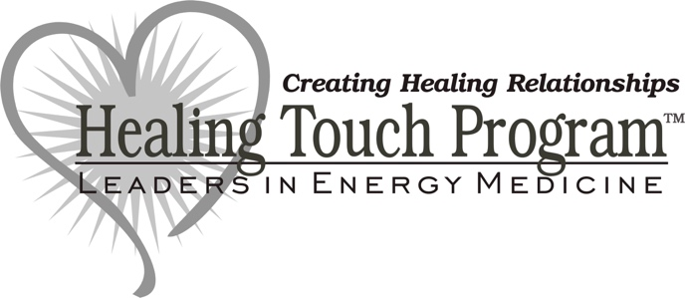
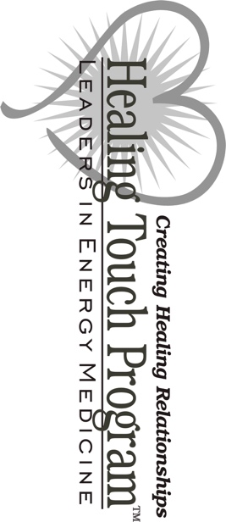

Your Return Address here

Level 1
August 13-14,2016
1250 E County Line Rd. Indianapolis, In 46227



